Marketing 411 Project 1 iFood
We have taken on a new client, iFood, a Brazilian company. Choose one of the two business objectives below. Use the customer data to investigate the objective and recommend actions that iFood could take.

Business objectives

Option 1 Ineffective targeting
iFood wants to create more effective targeted campaigns. Analyze the last campaign using Response (1 = accepted the offer; 0 = did not accept). Which types of customers were most responsive, and which were not?
Connect findings to a decision. Identify which groups iFood should prioritize in a future campaign and explain why. Consider both how responsive a group is and how many customers it includes.

Option 2 Low conversion users
iFood has noticed that some customers visit its website frequently but make few or no website purchases. Identify these customers, describe how they differ from other customers, and suggest ways to encourage purchases.
Connect findings to a decision. Identify potential ways iFood could encourage purchases for the target group of customers. Consider customer profiles and the types and amounts of products being purchased by different customers.

Data
Start from the raw ifood.csv file and use the data dictionary on the next page to interpret the variables. Clean and modify the data as needed for your chosen objective. You may create customer groups, such as income brackets, when useful. Explain your choices and document how you handle missing or unusual values. Include well-commented code so the analysis can be reproduced from the raw file.

Data dictionary
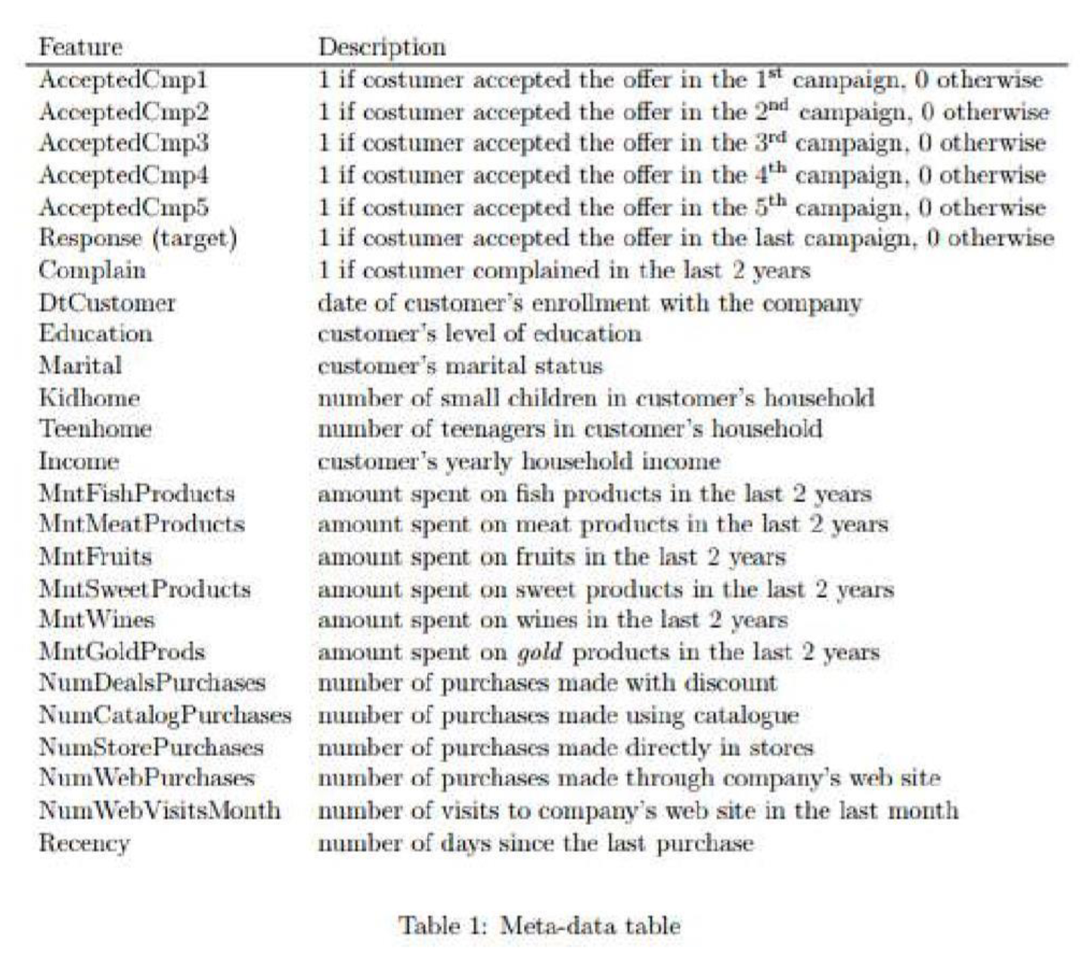

Deliverables

Deliverable 1 Analysis document
Submit a rendered Word document containing all code used for data wrangling, analysis, and initial visualizations. Include the resulting output and fully rendered plots with descriptive titles and labeled axes. This document is intended for technically focused colleagues at your company.
Use clearly labeled sections, well-commented code, and written descriptions to explain what you did, why you did it, and what the results mean. Someone who is unfamiliar with your code or data should be able to read the descriptions in the file and understand what was done. Define important variables and customer groups, explain key data preparation choices, and interpret the results in relation to your chosen business objective.

Deliverable 2 One page executive summary
Submit a well-written, one-page executive summary for an iFood manager. Use short sections with descriptive headings and plain language. The summary should stand on its own and cover the following content:
Business objective. State the problem you investigated, why it matters to iFood, and the business decision your analysis supports.
Approach. Briefly explain at a managerial level what customer data you examined and which comparisons you used to address the problem.
Key findings and implications. Present the most important results, supported by a few specific numbers or comparisons. Explain what those findings mean for the business and any limitations that materially affect the decision.
Recommendation. Recommend a concrete action tied to your findings. Identify the customers or behavior it addresses and, where appropriate, a next step to test the recommendation or resolve uncertainty.
For the executive summary, leave out code and detailed technical procedures, such as step-by-step data cleaning, standardization, or cross validation. Mention a data issue only when it changes how a manager should interpret the findings or act on the recommendation.

